Demographic Data Manager

.NET Demonstration Project for the Department of Veterans Affair

Robert Bonachea August 1st, 2018

# Technology and Installation

#### Technologies Used

* IDE – Visual Studio 2017
* Language – C#
* Web framework – ASP.NET MVC 4.6.1
* Database Mapping –Entity Framework
* Architecture – Layered Design (Onion Architecture)
* Dependency Injection – Ninject
* HTML Template - Razor
* Database – MS SQL 2017
* Scripting – jQuery
* CSS – Bootstrap / Custom

#### Project source code

Once you have cloned or downloaded the repository from GitHub and opened it in Visual Studio you should see the following:

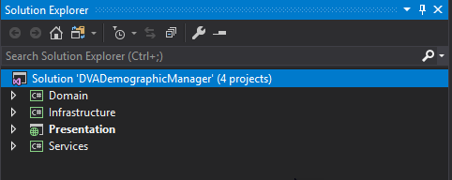

**Domain** – Contains Base Business Entities; POCO classes

**Infrastructure** – Data access and Repository Layer

**Services** – Responsible for moving data from domain layer

**Presentation** – Responsible for creating / displaying user interface. Handles user interaction *Next, we will configure the project.*

***Configuration***

To configure a **connection string** for SQL Server in the **Web**.**config** file, open the **Web**.**config** file in the root directory of Presentation Web project.

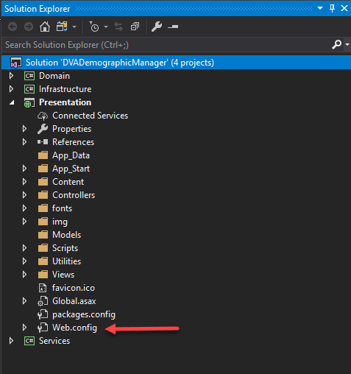

Locate the connectionStrings element @ Line 12 (Integrated Security)  
Update the **ServerName** with the location information for your MS SQL Server  
Ex. DVASQLServerA  
  
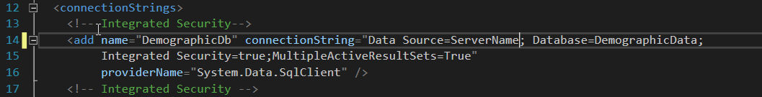

Note: The above connection string is utilizing Integrated Security for connection purposes. If you are utilizing SQL Server Security, comment out the 1st connection string and utilize the 2nd one supplying a **User Name** and **Password** as well as the **Database Server Name**  
  
  
  
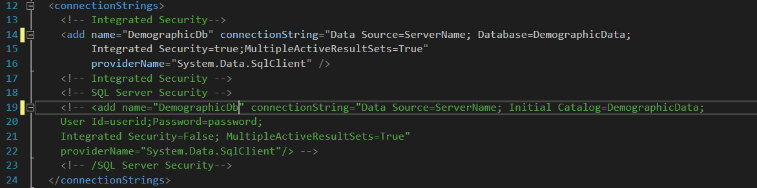

*\* The database does not need to exist as Code First will create it in the next steps.*

Prior to the creation of the database, Clean and Build the Project. This should install any missing packages from NUGET *1. Right Click the Solution Name and select Clean. (Output window)*

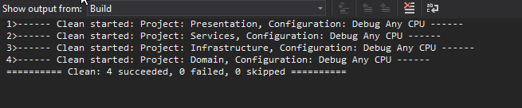

*2. Right Click the Solution Name and select Build. (Output window)*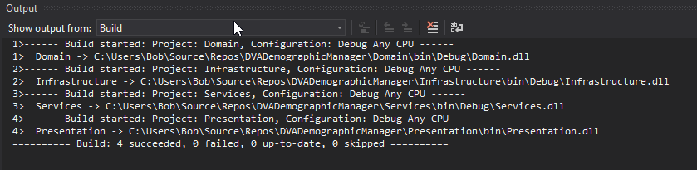

***Database Creation and Seeding***

1. ***Open the Package Manager Console***
   1. ***Ensure that the selected Default Project is set to: Infrastructure***

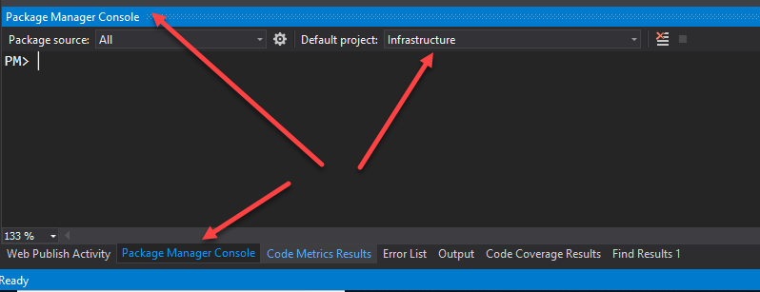

1. ***At the prompt PM>*** 
   1. ***Type in: Update-Database***
   2. ***If you wish to see verbose information as this command runs type in:  
       Update-Database -verbose***

***Ex.***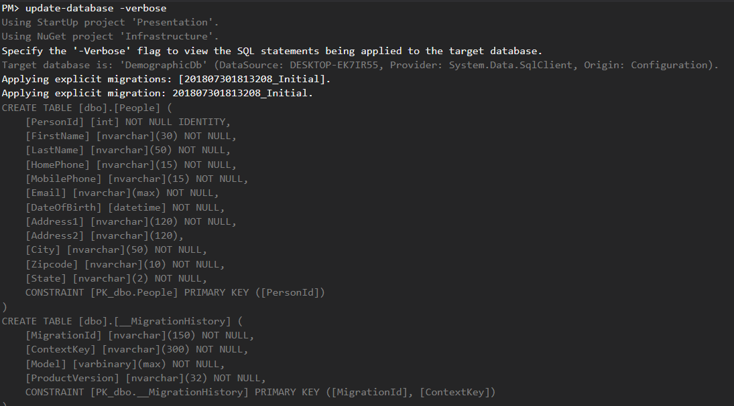

***This command will also seed the database***

**After this is completed, if you open your database using SQL Server Management Studio you will see that the database has been created.**

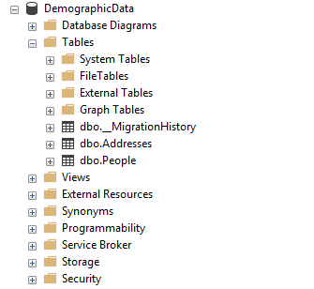

**Next, we will set the Presentation web project as the Startup project by right clicking the project in the Solution explorer and selecting: Set as StartUp Project.**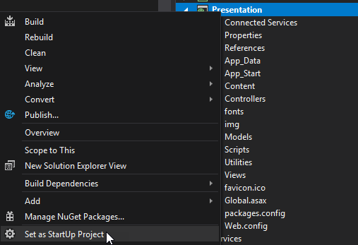

**You will now be able to launch the program via the F5 (Debug) or CTRL + F5 (Start without Debugging) commands from within Visual Studio.**